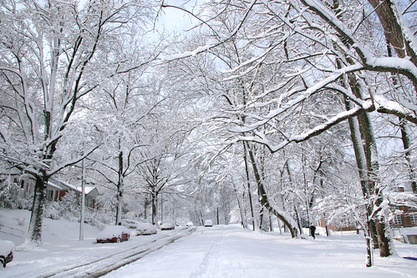
This Photo by Unknown Author is licensed under CC BY-NC
Important Notice: School Closure Tuesday 6th January
Due to ongoing severe weather conditions and the inability to ensure sufficient staff-to-pupil ratios, the school will remain closed tomorrow, Tuesday 6th January.
We are working hard to ensure a safe reopening and plan to reopen on Wednesday 7th January.
Thank you for your understanding and support.

